Food Authenticity Paper for JAOAC

# ***Abstract:*** 250 Words

# Introduction:

Food fraud is defined as the intentional adulteration or misrepresentation of foods and food ingredients for economic gain and is estimated to impact the food industry by $40 billion each year [REFS]. Economically motivated adulteration (EMA) does not just have financial consequences—it can also be a food safety issue with significant public health consequences. Some well-known examples of EMA include the adulteration of dairy products with melamine in China, which sickened nearly 300,000 babies, and killed 6 infants, [REF] and the misbranding of industrial–grade rapeseed oil, sold as olive oil in Spain, which caused 20,000 illnesses and at least 300 deaths [REF].

The economics of the global rice trade make rice an attractive target for criminals. More than 3.5 billion people depend on rice for as much as half of their daily calories [REF]. Asia accounts for 90% of global rice consumption, but rice is also the fastest-growing food staple in Africa and in Latin America [REF]. Fraud in the rice supply has been known for some time and typically involves the substitution of lower-quality rice for premium produce. For example, substitution of Basmati or Thai Hom Mali rice, which are both prized for their aroma and flavor is common. [REF]; as is the substitution of Wuchung rice (a geographical indication (GI) protected rice in China). Following the uncovering of a scandal in 2010, it was reported that ten times more Wuchang rice was sold than was produced1; West African countries including Ghana, Nigeria and their neighbors have experienced numerous cases of poor-quality rice in their markets [REF]. More specifically, expired or poor-quality rice is normally bagged and re-branded with counterfeit labels that consumers associate with high-quality rice [REF].

Here, we describe results from a research project, led by Professor Chris Elliott from the Institute of Global Food Security at Queen’s University Belfast, UK, focused to understand and address food fraud issues specific to rice. An international team representing some of the major producers, exporters and consumers of rice was assembled, including partners from China, India, Vietnam, Ghana, Ireland, the United Kingdom, and the United States. Fraud in rice is not ubiquitous; different countries face very different challenges requiring tailored solutions. Therefore, we developed a use-case approach for rice fraud in China, Ghana, India and Vietnam to explore the feasibility of using a single testing approach as a solution to address distinct and complex real-world circumstances.

Analytical technologies, including spectroscopic techniques, molecular or genome analysis, and mass-spectrometric methods have been developed and applied for the determination of authenticity in foods [REF]. For this project, we employed a two-tiered system of testing technologies, for detecting rice fraud in global supply chains. The first tier consists of a rapid screening method, based on a small hand-held (and field-portable) molecular spectroscopic technique that provides end-users with a rapid, low-cost, and easy-to-use “food fingerprinting” technique. This technology can be used by stakeholders across the entire food supply chain to quickly screen samples for fingerprint anomalies. The second tier employs a much more rigorous, laboratory-based confirmatory analysis technique that uses spectroscopic techniques such as LC-MS/MS (QTOF), GC-MS or ICP-MS for detection, quantitation, and confirmation of anomolous screening results. The most appropriate technique is selected based on the queston being asked of the sample.While the use-cases presented here are focused on rice, it is envisaged that the two-tier approach could be used with a wide range of commodities vulnerable to fraud.

# Experimental Section:

## Rice samples:

The Institute of Global Food Security at Queen’s University in Belfast, UK, has a library of over 1,000 authentic polished white rice samples collected over several years. This library represents different rice varieties and countries of origin. Project partners collected traceable polished white rice samples in-country, over the two year project thus providing not only variability in source of rice but also in harvest, processing batches and storage conditions. All rice samples collected in-country were sub-sampled and shared with the Institute for Global Food Security.

## Instrumentation

### Handheld NIR

Each of the partners in the project received a SCiO instrument for in-country scanning. The SCiO is a small handheld near infrared (NIR) scanner, manufactured by Consumer Physics, measuring 18.8 x 40.2 x 67.7 mm and weighing 35 grams. It works through a phone-based App to record NIR spectra between 740 and 1070 nm. scans take less than 5 sec 1. All spectra were stored in Consumer Physics cloud database. Users access their data through a browser-based App called ‘The Lab’. This App allows users to pre-process data, develop and validate their own models before publishing them for others to use. Project partners shared a single researcher license login that allowed them to store all project data in one account. This researcher license allowed spectral data to be exported from the cloud for manipulation in other software. All participants underwent a one-week training course in instrument use and chemometric model development and validation at the Institute for Global Food Security.

### LC-QTOF

Analysis were carried out using an Agilent Infinity 1290 liquid chromatography system coupled to an Agilent 6545 QToF with a Jet Stream ionisation source operating in positive mode with the following parameters: mass range, 50−1200 m/z; capillary voltage, 3.5 kV; nozzle voltage, 300 kV; gas temperature, 240 °C; drying gas (nitrogen), 11 L. min-1; nebulizer gas (nitrogen), 35 psi; sheath gas temperature, 320 °C; sheath gas flow (nitrogen), 11 L. min-1; fragmentor, 110 V; All Ion mode; acquisition rate 0.1 scan.s-1.

Chromatographic separation was performed on an Agilent Zorbax Eclipse Plus C18 RRHD column (50x2.1 mm, 1.8 µm) maintained at 45 oC with a flow rate of 0.5 mL.min-1 with the following gradient using water with 0.1 % formic acid and methanol with 0.1 % formic acid as mobile phase A and B, respectively: starting at 99 % A to 95 % A over 1 min, then linear gradient from 95 % A to 5 % A over 6 min, then from 5 % A to 1 % A over 2 min, then returned to initial condition with 99 % A over 0.2 min.

### ICP-MS

Agilent 7900 ICP-MS was utilized for multi-elemental profiling. The instrumental setting and operative conditions were adopted from a previous study 2 with modifications (RF power of 1550 W, RF matching of 1.85 V, and carrier gas flow rate of 1.05 L·min-1). In this study, 30 elements (B, Na, Mg, Al, K, Ca, Sc, Ti, V, Cr, Mn, Fe, Co, Ni, Cu, Zn, Ga, Ge, As, Se, Rb, Sr, Nb, Mo, Ag, Cd, Cs, Ba, Hg, Pb) in rice was detected.

### GC-MS

Samples were analysed using GC gas chromatograph coupled to a mass spectrometer (Agilent). Full scan mass spectra were acquired in the mass range of 45-750 Da at a rate of 1 scan s-1 with an initial solvent delay of 6 min. The injector, ion source and transfer line temperatures were set at 270 °C, 220 °C and 280 °C respectively. The initial oven temperature was held at 50 °C for 1 min, increased to 170 °C for 2 minutes at a rate of 10°C min-1 and finally increased to 280 °C for 1 min at a rate of 30 °C min-1. Helium was used as a carrier gas at a flow rate of 1 ml min-1. Samples exposed to SPME PDMS/DVB/CARBOXANE fiber was injected into the HP-5 MS capillary column consisting of a stationary phase of 5 % phenyl 95 % methyl polysiloxane in the splitless mode. Detection was achieved using a mass spectrometer in electron ionization mode at 70 eV. Overall samples run time is 20 minutes.

## Protocols

### Handheld NIR sample preparation and analysis

Polished white rice was analyzed as whole grains without any further sample preparation. Sufficient sample was dispensed into a glass petri dish to cover the base and to a depth of approximately 10 mm when evenly distributed. Samples were scanned statically from underneath, through the glass, in triplicate with repositioning of the SCiO device between scans to ensure averaged scan data would be representative of the larger sample.

### LC-QTOF sample preparation and analysis

Polished white rice was milled using Hario Skerton Plus Ceramic coffee grinder then sieved using Glenammer sieves 106 mic (800 microns). One hundred milligrams of milled rice was weighed using an analytical balance. The analytes were extracted with 2 mL of water (18.2 MΩ/cm)/LC–MS Chromasolv [methanol](https://www.sciencedirect.com/topics/chemistry/methanol) (4:1, v/v) by vortexing for 10 min at 2500 rpm, followed by sonication for 15 min at maximum frequency. After centrifugation at 10,000 g for 10 min at 4 °C, 0.5 mL of the supernatant was transferred to a fresh tube and solvent evaporated for 8 hours using an Eppendorf Concentrator Plus at room temperature with aqueous setting. Next, the extract was reconstituted in 0.3 mL of ultra-pure water, filtered through a 0.22 μm Costar Spin-X Centrifuge Tube Filter (5,000 g at 4 °C for 10 min) and transferred into LC-MS vials for the LC-HRMS analysis.

### ICP-MS sample preparation and analysis

0.5 g of rice grains was directly digested by 6 mL of concentrated HNO3 (70%) in a digestion vessel, in duplicate. The vessel was placed in fume hood overnight and then transferred to the microwave digestion instrument. The digestion temperature of 180 °C was gradually reached within 15 min, and held for 20 min. The digestion was completed when the digestion solution turned clear. The solution was cooled down to room temperature and diluted with distilled water to 50 mL, in metal-free plastic tube.

### GC-MS sample preparation and analysis

3 grams of rice samples were weighed into a 10 ml head space vial. Samples were incubated with PDMS/DVB/Carboxane fiber for 5 min at 70 °C. Fiber desorption was performed for 2 minutes at 270 oC.

### Model building

#### Handheld NIR

Classification models where built and validated for spectral data using several different applications. Initial models were built using Consumer Physics ‘The Lab’ browser-based interface which allows users to select and apply a set of pre-processing functions and develop models using a Random Forest algorithm. A separate sample set was then used for validation. Project partners also processed the data in various alternative software such as Matlab (MathWorks) and Simca 15 (Sartorius Stedim) which allows for the selection of different pre-processing and classification algorithms. Through this procedure the models that yielded the best internal cross-validation statistics and, where available, the most correctly identified Validation set samples were identified for addressing the specific needs of each partner.

#### LC-QTOF

Raw data files were processed using MassHunter Profinder 10.0 software then exported to Mass Profiler Professional 15 or Simca 15.0 for further data processing/filtering and/or multivariate analysis.

#### ICP-MS

The data was first pre-processed by taking logarithmic transformation and then split into training and testing set by ratio of 80:20. Partial Least Square-Discriminant Analysis (PLSDA) was implemented in RStudio with additional package “mixOmics” and “ropls”. The PLS-DA model was constructed with training set and optimized using 5-fold cross-validation for 10 times. The optimized model was then independently validated against testing set and the overall accuracy rate was calculated.

#### GC-MS

Spectral files were pre-processed using MassHunter software. Multivariate statistical analysis was performed by using Metaboanalyst. Normalised data was used for multivariate analysis to remove the offsets and adjust the importance of high and low abundance metabolites to an equal level. PCA was performed to identify clustering patterns. Further, supervised Partial Least Square-Discriminate Analysis (PLS-DA) was applied. The developed PLS-DA model was validated using the cross-validation method and its quality assessed on Accuracy, R2 and Q2 scores. Furthermore, the models were validated using permutation tests.

# Results and Discussion

## Use Case 1: India

Basmati rice, known as the ‘queen of fragrance’, is famous for its fragrance and delicate flavor. The aroma is due to the presence of a chemical called 2-acetyl-1-pyrroline, which is 12 times more abundant in Basmati than any other rice [REF i1]. Basmati is a healthy ‘Supergrain’. It is gluten-free and low in fat. It contains all eight essential amino acids, folic acid, and is very low in sodium and has no cholesterol in its composition. It has a low to medium glycemic index as compared to other non-Basmati rice, meaning that energy is released at a slower, steadier rate leading to a more balanced level of energy [REF i2].

Basmati is grown only in the foothills of the Himalayan mountain range. This is its Geographical Indication. The major areas of cultivation of basmati rice are in the states of Jammu & Kashmir, Himachal Pradesh, Punjab, Haryana, Delhi, Uttrakhand and western Uttar Pradesh. There are approximately 36 traditional strains of Basmati, with only about 5 to 6 being traded in the open market at any one time [REF i3]. India is the leading exporter of the Basmati rice to the global market. Major export destinations for 2018-19 were Iran, Saudi Arab, Iraq, UAE, and Yemen [REF i4]. More than 44 million metric tonnes of basmati rice, with an approximate market value of $4.7 billion USD were exported in 2018 [REF i5].

Basmati rice, prized for its unique flavor and fragrance, is vulnerable to fraudulent variety claims and substitution fraud. The main goal of the Indian rice study was to develop a two-tiered method to identify and protect the more expensive Pusa 1121 and Taraori rice varieties; ensuring that they have not been substituted. In total, Green Saffron Ltd provided 1399 samples representing 7 basmati varieties: Pusa 1121 (n= 250); Pusa 1509 (n=149); Sugandha (n=250); Taraori (n=150); Shabnam (n=250); Duplicate basmati (n=200); and Sharbati (n=150)). Pusa 1509 and Sugandha are considered potential adulterants of Pusa 1121. Whilst Shabnam, Duplicate Basmati and Sharbati are considered potential adulterants of Taraori.

### Handheld NIR

Samples were scanned using the SCiO instrument. Sample data was divided into a Reference set (n= 934), to build the models, and a Validation set (n=465) to test the models. Chemometric models were developed using SIMCA 15 to differentiate the varieties.

Multiple pre-processing techniques were applied to spectral data before multiclass models containing Pusa 1121 and its adulterants were built alongside models for Taraori and its adulterants. In total, more than 18 multiclass models were generated and tested using the Validation set. The best models for Pusa 1121 and Taraori, based on the number of correctly identified samples in the Validation set, are presented in Figure 1a and Figure 1b respectively. Spectral data that had undergone Standard Normal Variate (SNV), first derivative and Savitzky-Golay (SG) smoothing pre-processing followed by model building using Orthogonal Partial Least Squares-Discriminant Analysis (OPLS-DA) were found to produce the best multi-class models in terms of predicted results for the Validation set. i.e. none of the adulterants were misclassified as Pusa 1121 and only 2 out 50 Sharbati samples were misclassified as Taraori. Performance improved when binary models were used eg Pusa 1121 vrs adulterants, Figure 1c, and Taraori vrs adulterants, Figure 1d. There was no misclassification of the adulterants when the binary models were tested.

This demonstrates that both multiclass and binary models can be used to rapidly screen for adulteration in the field, with reasonable accuracy, allowing for suspect samples to be returned to the lab for tier-two testing.

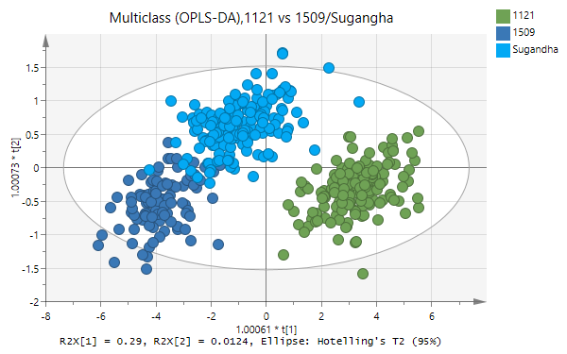

**a**

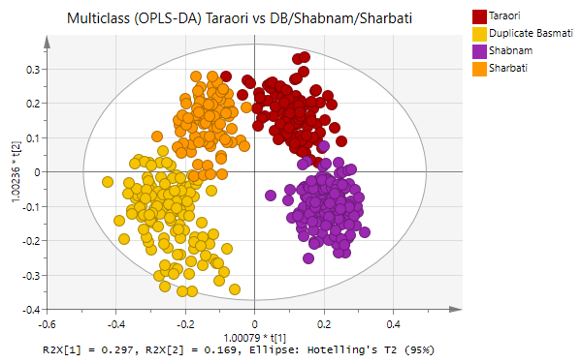

**b**

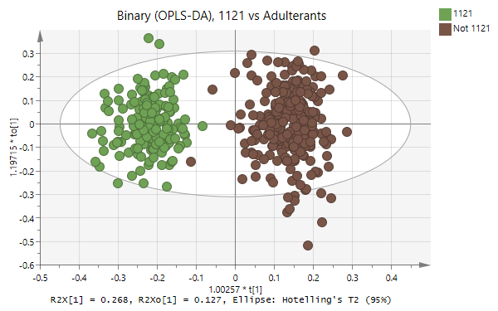

**c**

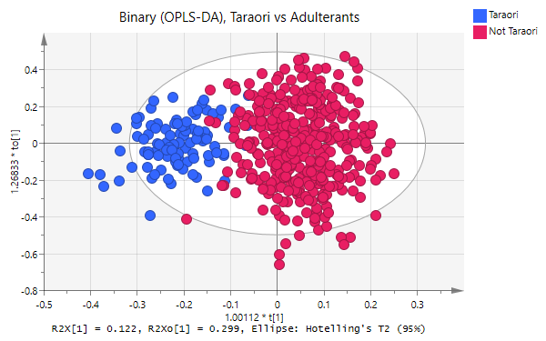

**d**

Figure 1 Chemometric models to class various basmati varieties of rice. a: Multiclass OPLS-DA model containing 1121 and its two adulterants, b: Multiclass OPLS-DA model containing Taraori and its three adulterants, c: Binary OPLS-DA model containing 1121 and its adulterants and d: Binary OPLS-DA model containing Taraori and its adulterants.

### GC-MS Indian rice samples

Volatile Organic Compound (VOC) profiles, for 10 to 15 samples from each of the seven different varieties of Indian Basmati rice samples, were analyzed using Head space SPME combined with GC-MS. tell us why we are looking at VOC? What information does this analysis provide? Why have we selected to use GCMS? How are LCMS. ICPMS and GCMS complimentary?

In the first model, PCA analysis identified the classification between Duplicate, Pusa 1121, Shabnam and Sugandha rice samples. Frist two principle components (PCs) explained 79.5.% of total variation. Duplicate rice samples clustered separately from other rice sample groups with high negative loadings in PCA scores plot. PC2 explained the variation between Pusa 1121, Shabnam and Sugandha rice samples. Internal cross validation with independent data set shown good Q2 (0.97693), R2 (0.9963) and accuracy (1.0). Hierarchical cluster analysis (HCA) shown clear sample classification based on the VOC profiles. Pusa 1121, Sugandha samples contains high VOC profile content than Shabnam with least in Duplicate rice samples.



Figure 1: 1a Principal component analysis of Duplicate, Pusa 1121, Shabnam and Sugandha rice samples. 10-15 samples were analysed from each group. 1b. HCA of above Indian rice sample groups



Figure 2: 2a Principal component analysis of Duplicate, Pusa 1509, Sharbati and Taraori rice samples. 10-15 samples were analysed from each group. 2b. HCA of above Indian rice sample groups.

Principal component analysis of Pusa 1509, Sharbati, Taraori and Duplicate samples identified clustering of sample groups, explained total variation of 84%. Duplicate rice samples clustered separately from Pusa 1509, Sharbati, Taraori groups with high negative loadings in along PCA1 (Figure 2A). PC2 explained the variation between Sharbati and Pusa 1509, Duplicate, Taraori rice samples. Internal cross validation with independent data set shown good Q2 (0.89417), R2 (0.98958) and accuracy (1.0). Hierarchical cluster analysis (HCA) shown clear sample classification based on the VOC profiles of Basmati rice samples (Figure 2b). Duplicate rice samples contain low VOC profile content than Pusa 1509, Sharbati, Taraori rice samples.

We have tested GC-MS VOC profiling to screen commercial basmati rice samples, adulterated samples and normal long grain rice samples. PLS-DA analysis identified clear classification of Indian basmati rice samples (Sugandha) from other long grain rice samples and 50% adulterated samples along first component with accuracy 1 (Figure 3a). Similarly, models identified clear classification of Commercial basmati rice samples from 50% adulterated basmati rice samples, long grain rice samples (figure 3b). In both models, components explained clear variation between long grain rice and adulterated basmati rice samples.

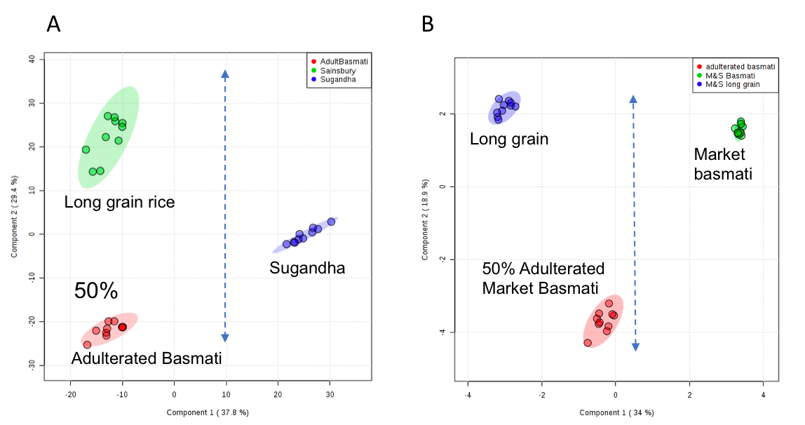

Figure 3: a) PLS-DA analysis of Indian Sugandha, adulterated basmati and long grain rice samples. b) PLS-DA analysis of commercial basmati rice samples, adulterated and long grain normal rice samples.

Summary of project so far, and what are next steps?

## Use Case 1: China

Worldwide, China is the biggest producer of paddy rice, with approximately 220 million metric tons produced in 2018 3. Geographically, the main rice production regions are in north-eastern China and areas along the Yangtze river. Originating in 19th century Europe, geographical indication (GI) is a designation assigned to certain products from a specific geographical origin and with particular qualities or reputations which are associated with that origin. With rising standards of living, there is a strong demand for GI products in China. There are more than 60 Chinese rice cultivars with GI designations, but none are more prized than Wuchang rice. Due to the dramatic difference between the market demand for Wuchang rice and the actual amount that can be produced, fraudulent behavior such as partial substitution with low quality rice has been frequently reported in recent years. [4 ANOTHER REF AS WELL c1] Since that it is challenging to visually differentiate GI rice from non-GI ones with reliable accuracy, there is a great need to develop an easy, reliable, and “fingerprinting”- based authentication toolbox to prevent the case of adulteration.

How many harvests? What is the Consumption? How much is imported? How much exported?

What are most common type(s) of rice fraud in China? What can be/is being done to mitigate rice fraud in China?

### Handheld NIR

124 polished white rice samples were collected in China and scanned in triplicate on the SCiO according to the method described earlier. How where these samples obtained – markets? Growers? Please provide additional details so reader can determine if samples are “authentic” or not. These samples were divided to represent 5 different GI varieties: Panjin (Jilin) (n=52); Jingshan (Hubei) (n=20); Sheyang (Jiangsu) (n=19); Guigang (Guangxi) (n=14); and Wuchang (Heilongjiang) (n=19). All collected varieties were identified as high-quality rice. How? Numerous pre-processing techniques were applied to the data and chemometric models developed, in both ‘The lab’ and Simca 15, to distinguish between the varieties, data not shown.

Using ‘The Lab’, the best, based on internal cross-validation, Random Forest model was obtained after averaging the sample replicates then applying, in order: SNV; Subtract Average; Second Derivative (window: 35, quadratic polynomial); and Wavelength Z-score to the full spectral range produced by the SCiO. Figure 2a shows the confusion table generated by ‘The Lab’ under these conditions. Using Simca 15, the best model, based on internal cross-validation, was generated using an OPLS-DA algorithm on data that had undergone: SNV; first derivative (window: 15, quadratic polynomial); and Savitzky-Golay filtering (window:15) preprocessing, Figure 2b.

Figure 2a shows that, during internal cross-validation, all Panjin, Guigang and Jingshan GI varieties have been correctly classified in all instances while Sheyang and Wuchang have been misclassified 6 % and 5 % of the time, respectively. Sheyang samples (6 %) where misclassified as Wuchang and Wuchang samples (5 %) were misclassified as Panjin. Figure 2b shows clear clustering within GI varieties. The robustness of these model can only be tested when additional samples have been collected. However, if either model proves to be robust through a comprehensive validation, then the SCiO could be used for rapid in-field assessment of GI status. Having a robust, reliable, rapid field-based screening technology would not only protect sellers from unfair competition through fraudulent vendors but also protect those consumers who choose to purchase these GI varieties.

**a**

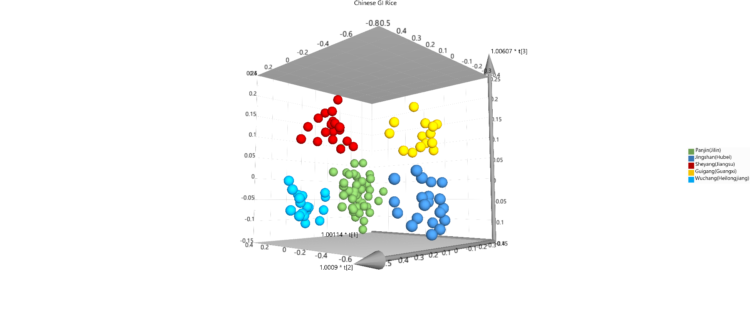

**b**

Figure 2a: Confusion table for optimal Random Forest model developed in ‘The Lab’ using Chinese rice samples. Figure 2b: optimal model for Chinese rice samples, produced in Simca 15.

### ICP-MS

Inductively coupled plasma mass spectrometry (ICP-MS), a powerful analytical tool that quantitatively determines the level of both metal and non-mental elements, has the advantages of wide dynamic range, high throughput and relatively easy sample preparation{Wadood, 2020 #29}. Evidences show that the element composition in plants are largely determined by factors such as soil characteristics and agricultural practices {Chung, 2018 #8}{Zhang, 2010 #31}. By far, elemental profiles from plants obtained by ICP-MS, has been used to identify the geological origins {Cheajesadagul, 2013 #32}{Maione, 2016 #33}

In this study, one hundred and thirty-one GI rice samples were directly collected from the rice processing factories with reliable credibility from five provinces in China. For simplicity, we named those samples as WC (n=20), DJX (n=16), PJ-YF (n=35), PJ-LX (n=20), JSQ (n=20), and SY (n=20). They were then analyzed with Agilent 7900 ICP-MS. The data from training set was subjected to PLS-DA in order to construct a model for differentiating six GI rice altogether. As shown in Figure 3, overall the first two components explained nearly 50% of the total variance. Specifically, PJ-YF, JSQ, and DJX can be clearly separated from the other rice; while PJ-LX, SY, and WC rice were clustered together. Internal cross-validation showed that the model has good predictability: R2X= 0.859, R2Y= 0.935, Q2Y= 0.907. Further external validation was conducted using the testing set to determine the accuracy of the PLS-DA model. The prediction accuracy for each GI rice is shown in Table 1, and the overall predictive accuracy for all six GI rice was 88.46%.

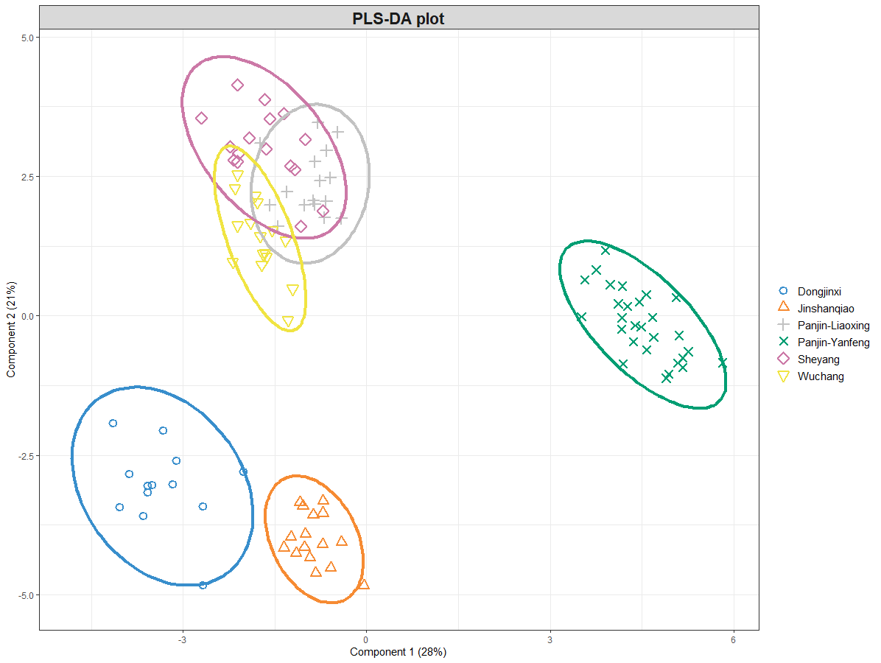

Figure 3. PLS-DA score plot derived from 30 elements in Six GI rice.

|  |
| --- |
| **Predicted** |
| **Truth** | | | | | | |
|  | **Dongjinxi** | **Jinshanqiao** | **Panjin-Liaoxing** | **Panjin-Yanfeng** | **Sheyang** | **Wuchang** |
| **Dongjinxi** | 100 % | 0 | 0 | 0 | 0 | 0 |
| **Jinshanqiao** | 0 | 100% | 0 | 0 | 0 | 0 |
| **Panjin-Liaoxing** | 0 | 0 | 100% | 0 | 0 | 75% |
| **Panjin-Yanfeng** | 0 | 0 | 0 | 100% | 0 | 0 |
| **Sheyang** | 0 | 0 | 0 | 0 | 100% | 0 |
| **Wuchang** | 0 | 0 | 0 | 0 | 0 | 25% |

Table 1. Confusion matrix derived from external validation on the testing set

### GC-MS China Rice samples

We analysed the VOC profile, as described earlier, of seven different types of China rice samples from different geographical regions, including, Daohuaxiang, Guigang, Liaoxing, Qiaomi537, Sheyang, Wuyoudaobai and Yanfeng. PLS-DA analysis was performed on the data matrix obtained from GC-MS spectral files. Performing PLS-DA model on VOC profiling of Daohuaxiang, Sheyang, Wuyoudaobai and Yanfeng identified clear classification of Daohuaxiang from the other three rice sample groups along component one with good Q2 (0.9737), R2 (0.99324) and accuracy (1.0), Figure 4. Similarly, performing PLS-DA on VOC profiles of Guigang, Liaoxing, Qiaomi537 identified classification with good Q2 (0.89417), R2 (0.98958) and accuracy (1.0) along component 1, Figure 5. Prediction accuracy further tested with Permutation test (p<0.01).

Assess strengths and limitations of the approach

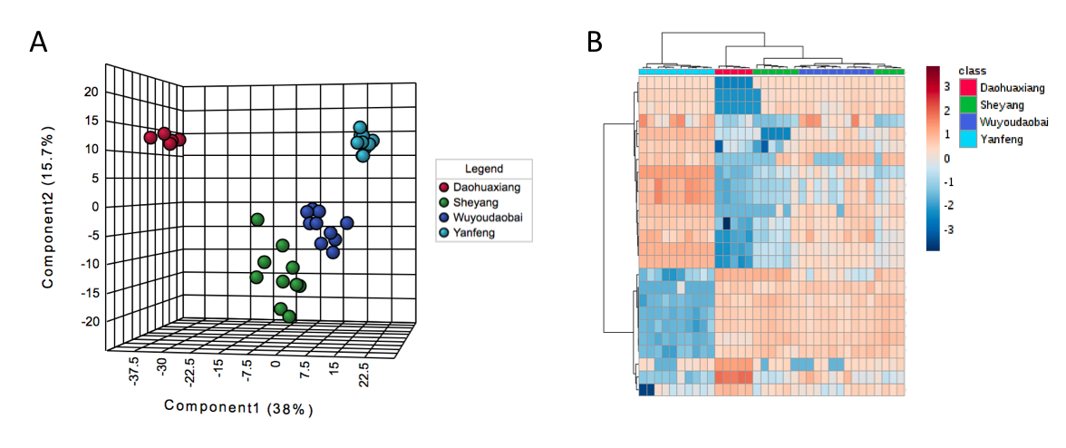

Figure 4: PLS-DA analysis of Daohuaxiang, Sheyang, Wuyoudaobai and Yanfeng with 10 to 15 samples from each group

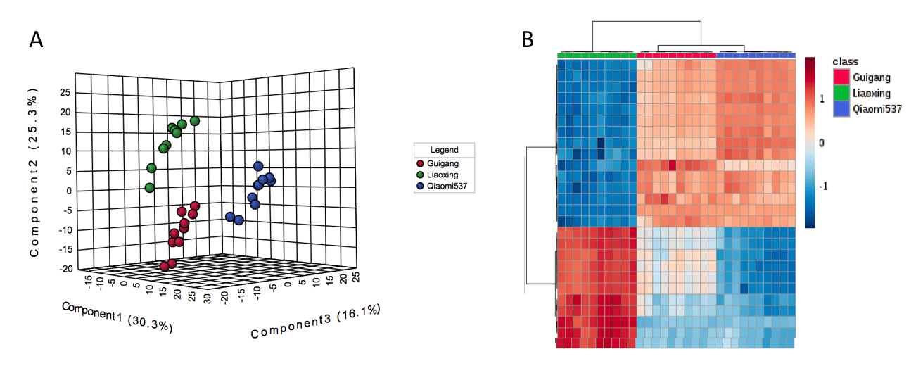

Figure 5: PLS-DA analysis of Guigang, Liaoxing, Qiaomi537 with 10 to 15 samples from each sample group

Something pulling together results from the multiple techniques. what are next steps?

## Use Case 2: Ghana

West Africa countries are net rice importers and in 2018, imported more than 7.6 million metric tonnes at a cost of $4 billion USD 5. In Ghana, rice has become a major staple food and consumption is higher than domestic production hence the need to import over 60 % of rice consumed [REF g1]. This has a huge impact on the local economy. The rate of import continues to rise. Records show that, between 2007 to 2015, Ghana spent $151 million - $1.2 billion on rice imports, mostly from Thailand, Vietnam, and India [REF g2]. In 2017, Ghana produced 721,610 metric tonnes of rice and consumed 1.3 million metric tonnes revealing a deficit of 580,300 tonnes. From 2015, the deficit has decreased from its peak at 608,602 tonnes. This is in part due to domestic production increasing (The report Ghana 2010).

There is a large diversity of rice quality in imported rice and there are frequent rumors that poor quality rice is flooding the local markets [REF g3]. This claim is worrying because it is extremely cumbersome to identify the integrity status of the rice consignments.

These challenges of huge imports coupled with sub-standard quality has compelled the government of Ghana to introduce a flagship program, “planting for food and jobs”, with a special emphasis on rice production. This program is forecast to increase rice production from 450,000 metric tonnes to 750,000 metric tonnes by 2020 (Business-Ghana 2019).

In certain circumstances both local grown and imported rice are subject to fraud. Many consumers in Ghana, show a preference for imported rice over local rice because they believe imported is higher quality. This has created a potential avenue for mislabeling of Ghana rice as imported rice Conversely, there are consumers who actively seek out Ghana rice to insure they are buying local in the belief that it is better. Studies have shown that consumers who prioritize local rice do so out of the perception that even though it is inexpensive, it has better nutritional quality 6. Furthermore, the increased production and consumption of local rice builds a more sustainable economy for Ghana and region

These divergent quality perceptions regarding quality have facilitated food fraudsters to cheat local consumers who are at the mercy of cumbersome quality control via slow detection methods.

Actual quality attributes including appearance (whiteness and glittering) of uncooked rice and taste/aroma for cooked rice is crucial to consumers in Ghana 6. Consumers also consider cooking quality (notable expansion and speed of cooking), absence of stones, percentage broken and absence of mold [REF g4]. These criteria often categorize rice into three distinct groups known as high quality, mid quality and low quality. However, beyond this, there are numerous brands in the market with poor quality attributes (mostly not easily identified by the consumer) masked by synthetic performed and white coloured (mostly toxic) all to deceive the consumer.

### Handheld NIR

Rice samples (n=680) were collected from local millers, and recognized retailers from seven regions in Ghana. Imported rice (from Thailand and Vietnam) was purchaed from recognised supermarkets in Ghana. Armed with the quality attributes, sensory analysis (1-6 point hedonic scale) was performed and the rice samples were further grouped into three distinct groups: high quality (n=x), mid quality (n=x) and low quality (n=x). Interestingly these grouping correlated to purchase price. Samples were scanned using the SCiO. Data sets were subjected to several preprocessing techniques indivudually and combined before PCAs were generated in Matlab.

Two major questions were asked; how to differentiate the quality of rice and how to identify locally grown Ghana rice from imported ones. PCAs built after MSC pre-processing provides clear cluster trends for each of the questions asked of the Ghana rice samples. For quality grades, the first three principle components explain 98.67% of the variation and whether the rice was locally grown or imported, the first three principle components explain 99.84%.

The handheld spectroscopic technique coupled with chemometric has been successfully used to rapidly differentiate three categories of rice (High quality, mid quality and low quality). In addition the techniques has been employed to differentiate between imported and locally grown rice to overcome re-bagging and mis-labelling, classification of rice samples from country specific (Ghana, Thailand, Vietnam).

### GC-MS Jasmine rice samples from Ghana

VOC profile of high- and low-quality jasmine from Ghana where analysed. PLS-DA analysis was performed on the data matrix obtained from GC-MS spectral analysis. Figure 6 shows that the first two components explained 71.3% of total variation. Principal component 1 shows clear difference in high quality and low-quality sample groups. Model validation with cross validation of independent data set gave good Q2 (0.97632), R2 (0.99931) and accuracy (1.0) presented in figure 4. Further permutation test analysis showed model validation with significance (p < 0.01). Hierarchical clustering analysis was further performed and showed clear separate clustering of High-quality jasmine samples from low quality jasmine samples from Ghana.

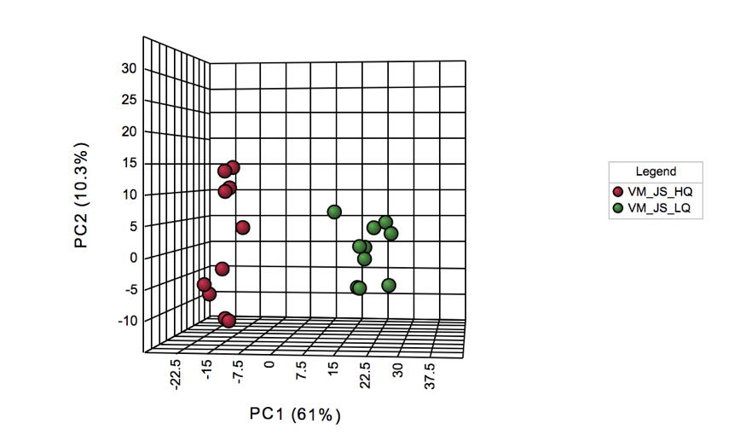

Figure 6: Principal component analysis of High quality and low-quality Jasmine rice samples from Ghana. 10 samples were analysed from each sample group.

## Use Case 1: Vietnam

* 1. Also used GC-MS to analyze VOCs: describe results
  2. Summary of project so far, and

Vietnam is the third biggest rice exported in the world, following only India and Thailand 3. In 2018 Vietnam exported 6 million metric tonnes of rice with an estimated market value of $3 billion USD [REF v1]. The average price of rice is $502 or is it $429, as stated in section that has been removed (refer to original version you sent) USD per metric tonne [Ref v2]. Vietnam enjoys two harvest each year, one in early spring and another in late summer.

There are 2 big issues in the Vietnamese rice market. The first issue is the export value. Vietnam does not currently have a national brand name, unlike India (Basmati), or Thailand (Hom Mali). Because Vietnam rice producers believe that the lack of a national brand limits the perceived value of Vietnamese rice exports, Vietnam is trying to build a national brand, but the communication for this brand is not efficient, and the rice importing countries still consider Vietnam rice as low quality. In addition, if some of Vietnam rice varieties is purchased at higher price, for example Dai Thom 8 or OM 6979, some rice manufacturers will mix with other lower price varieties in order to sell with lower price to gain the market share. This kind of fraudulent is one of a big headache for Vietnam rice manufacturers.

For the purpose of this study we define rice quality according to the cooking quality and the appearance of rice. The high-quality rice always has a bright surface, nearly transparent body, soft texture and good cooking quality. The low-quality rice has a hard texture and low cooking quality. The price of high-quality rice is about 20-25% higher than low quality rice. In the local market, there are more than 150 different brands. The most popular brands are always exposed to fraud risk in that fraudulent retailers mix low-quality rice into high value brands in order to get more benefit. The big companies try to protect their brands, but they can’t find an efficient tool for this. Moreover, as rice is not a high value product, using modern methods, with costly high-tech equipment is not a viable choice. Especially when considering that the number of sub-samples needed to be analysed to protect against fraud events would need to be increased compared to meeting statutory requirements for safety testing. In this instance a two-tier system makes perfect sense where sample screening can be increased using a low-cost portable device whilst only suspect samples need forwarded to the more expensive mass spec based methods.

In this study we differentiated between high value and low value rice. We collected 5 varieties: Dai Thom 8 (n=x); OM 5451 (n=x); OM 6976 (n=x); and IR 50404 (n=x) from 4 different provinces in Mekong delta, Vietnam: Can Tho; Dong Thap; Kien Giang; and An Giang.

In this collection, IR 50404 is considered as low-quality rice and this variety is often used to mix with the other rice to lower the price.

### Handheld NIR

Need experimental details added – how many samples etc see comment on the paragraph directly above this

### LC-MS

Olivier to add

### what are next steps – Duy to complete

# General Discussion

Towards the end of the project, several demonstrations, Figure 7, and workshops where held in Ghana, China and Vietnam. Rice industry stakeholders including farmers, processors, regulators, exporters, traders, and consumers, were invited in each country and from neighboring countries. The topic and nature of the workshops generated a lot of interest, with more than 180 participants in the Ghana workshop alone. The purpose of these workshops where to not only to disseminate information on the occurrence of rice fraud but also to demonstrate and discuss the use of the two-tier system, handheld NIR for in-field detection supported by laboratory based mass spec methods, to address the relevant rice authenticity concerns in each country specifically. Feedback was also collected on how Users could make practical use of a two-tier testing regime. Discussions around the two-tier system generated many talking points and excitement grew for the number of potential applications and follow-up activities where instigated.

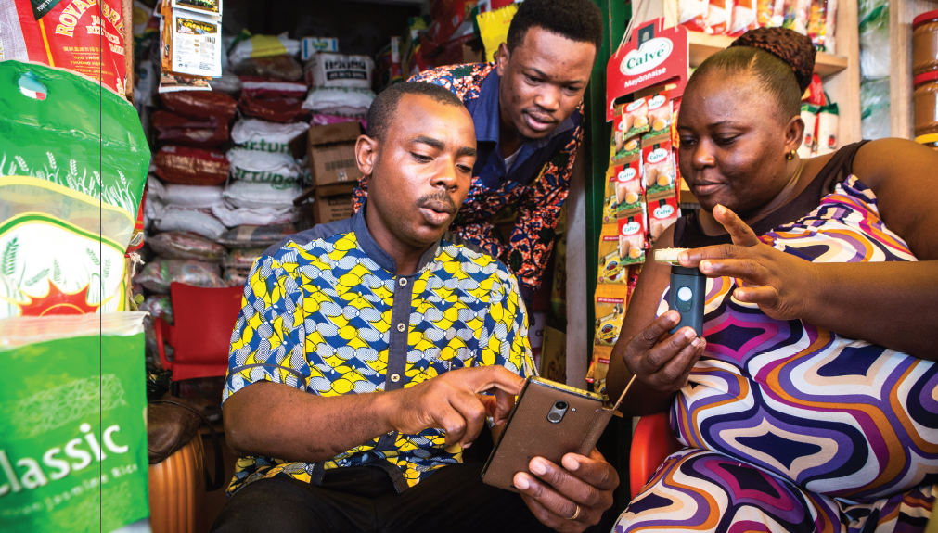

Figure 7: Demonstration being performed at a market in Ghana

Both the handheld NIR and mass spec methods have pros and cons. From an end-user perspective, the benefits of the handheld NIR method include: it is rapid, facilitating fast results; low cost, therefore does not significantly add to the cost of food and more samples can be analyzed; provides a degree of consumer confidence; can be performed with minimal training by anyone; and it is not confined to a laboratory. However, models are only as good as the databases used to generate them; and it remains a screening test, therefore legal decisions should not be based on its finding. The mass spec….

It is our belief that combining the screening and confirmation methods into a multi-tiered testing system is the best approach. They complement each other to provide the best solution to the end-user. Screening with the handheld NIR will facilitate increasing the number of samples to be analyzed and provide a fast positive release while identifying the suspicious samples that are then forwarded for the more sensitive mass spec methods for confirmation.

Through our initial discussions between partners it became clear that a “one size fits all” approach would not work, for example, India had no need for Chinese GI rice determination nor concern of distinguishing high- or low-quality rice. Adding these data streams into the Indian models would have cause unnecessary noise. Tackling each as an individual use case helped to meet country specific needs and this should be the approach taken in the future.

# Conclusion

The fact is that every technology brought to bear on the problem of food fraud has its strengths and limitations. Because there is not “perfect” solution, and because needs vary by use case (scenario) this is why we advocate a two-tiered system – recognizing the need for a fast screening which provides )some sort of quick (and pretty informative) test is powerful, but not infallible and certainly not defensible from perspective of prosecution of a crime.

# References

1 ConsumerPhysics. *Technology*, <<https://www.consumerphysics.com/business/technology/>> (2020).

2 Hopfer, H., Nelson, J., Collins, T. S., Heymann, H. & Ebeler, S. E. The combined impact of vineyard origin and processing winery on the elemental profile of red wines. *Food Chemistry* **172**, 486-496, doi:10.1016/j.foodchem.2014.09.113 (2015).

3 Statista. *Paddy rice production worldwide 2017-2018, by country*, <<https://www.statista.com/statistics/255937/leading-rice-producers-worldwide/>> (2019).

4 Rodriguez, L., Li, J. & Sar, S. Social trust and risk knowledge, perception and behaviours resulting from a rice tampering scandal. *International Journal of Food Safety, Nutrition and Public Health* **5** (2014).

5 Fiamohe, R., Demont, M., Saito, K., Roy‐Macauley, H. & Tollens, E. How Can West African Rice Compete in Urban Markets? A Demand Perspective for Policymakers. *EuroChoices* (2018).

6 Diako, C., Sakyi-Dawson, E., Bediako-Amoa, B., Saalia, F. K. & Manful, J. T. Consumer Perceptions, Knowledge and Preferences for Aromatic Rice Types in Ghana. *Nature and Science* **8**, 8 (2010).